Part A
Name:-
Roll No:-
Subject:- Data Structures and Algorithms
Program: B Tech/BTI CE
Aim:
To study and implement the concept of Linked list data structure.
Prerequisite: C++ Programming
Outcome: To implement queue and its operations.
- Theory:
Linked list is dynamic data structure in which elements can be inserted and deleted anywhere without shifting. In contract to fixed size in arrays, linked list can allocate memory to data elements during run time also.
A linked list consists of nodes that are dynamically created by allotting memory during run time. The node has two parts: data and pointer to next node.

Data Pointer to
next node

Figure 1. Linked List Node Structure

The linked list consists of node connected sequentially as shown in figure 2.
10 Pointer to
next node
2 Pointer to
next node

89 Pointer to
next node

67 Null Value

Figure 2. Linked List

The structure of the node in C++ is:
struct Node{
int num;
Node *next;
};
//Starting (Head) node
struct Node *start=NULL;

Linked lists contain a pointer variable START that stores the address of the first node in the list.

10 2000
start
12 NULL

Operations on Linked List
The primitive operations performed on the linked list are as follows:
- Creation
- Insertion
- Deletion
- Traversing
- Searching
Types of a Linked list:
Basically we can divide the linked list into the following three types in the order in which they are arranged.
- Singly linked list
- Doubly linked list
- Circular linked list

Singly Linked list
Traverse: Traversing a linked list means accessing the nodes of the list in order to perform some processing on them.
- Step 1: [INITIALIZE] SET PTR = START
- Step 2: Repeat Steps 3 and 4 while PTR != NULL
- Step 3: Apply Process to PTR-> DATA
- Step 4: SET PTR = PTR -> NEXT
- [END OF LOOP]
Step 5: EXIT
C++ function :
void display_all_nodes()
{
cout<<"The list contains the data entered:\n"; struct Node *temp = start;
while(temp!=NULL)
{
cout<<temp->num<<" ";
temp=temp->next;
}
cout<<endl;
}

Inserting at the beginning:
- Step 1: IF AVAIL = NULL
- Write OVERFLOW
- Go to Step 7
- [END OF IF]
- Step 2: SET NEW_NODE = Allot memory
- Step 3: SET NEW_NODE->DATA = VAL
- Step 4: SET NEW_NODE-> NEXT = START
- Step 5: SET START = NEW_NODE
- Step 6: EXIT
C++ function:
void insert_Node(int n)
{
struct Node *new_node=new Node; new_node->num=n;
new_node->next=start; start=new_node;
}

Inserting at the end:
Step 1: IF AVAIL = NULL
Write OVERFLOW
Go to Step 7
[END OF IF]
Step 2: SET NEW_NODE = Allot memory
Step 3: SET NEW_NODE->DATA = VAL
SET NEW_NODE->NEXT = NULL
Step 4: PTR=START
Step 5: Repeat Step 6 while PTR->NEXT != NULL
Step 6: SET PTR = PTR->NEXT
[END OF LOOP]
Step 5: SET PTR->NEXT = NEW_NODE
Step 6: EXIT

Delete a node with the given value
Step 1: IF START = NULL
Write UNDERFLOW
Go to Step 10
[END OF IF]
Step 2: SET PTR = START
Step 3: SET PREPTR = NULL
Step 4: Repeat Steps 5 and 6 while PTR->DATA != NUM
Step 5: SET PREPTR = PTR
Step 6: SET PTR = PTR-> NEXT
[END OF LOOP]
Step 7: SET TEMP = PTR
Step 8: SET PREPTR->NEXT = PTR->NEXT
Step 9: FREE TEMP
Step 10 : EXIT
TASK 1:
Write a C/C++ program to implement the following operations on a Singly linked list
- Insert a node at the beginning
- Insertion a node at the end
iii) Delete a node with the given value
iv) Traverse the list

Procedure:
- Open CodeBlock editor or visual studio editor and write the code in C++.
- Complile and run the code
Instructions:

- Copy code & paste in code section and output of Part B.

Part B
Code:
#include <iostream>
using namespace std;

class Node {
public:
int val;
Node* next;

Node() : val(0), next(NULL) {}
Node(int val) : val(val), next(NULL) {}
};

void insertAtBeg(Node*& head, int val) {
Node* node = new Node(val);
node->next = head;
head = node;
}

void insertAtEnd(Node*& head, int val) {
if (head == NULL) {
head = new Node(val);
return;
}

Node* temp = head;
while (temp->next != NULL) {
temp = temp->next;
}

Node* node = new Node(val);
temp->next = node;
node->next = NULL;
}

void deleteNode(Node*& head, int val) {
if (head == NULL) return;

if (head->val == val) {
Node* temp = head;
head = head->next;
delete temp;
return;
}

Node* prev = head;
Node* curr = head->next;

while (curr != NULL && curr->val != val) {
prev = curr;
curr = curr->next;
}

if (curr == NULL) return;

prev->next = curr->next;
delete curr;
}

void printList(Node* head) {
Node* temp = head;
while (temp != NULL) {
cout << temp->val << " -> ";
temp = temp->next;
}
cout << "NULL\n";
}

int main() {
Node* head = NULL;

insertAtBeg(head, 20);
insertAtBeg(head, 30);
cout << "After insertAtBeg calls:\n";
printList(head);

insertAtEnd(head, 40);
insertAtEnd(head, 50);
cout << "After insertAtEnd calls:\n";
printList(head);

deleteNode(head, 20);
deleteNode(head, 30);
deleteNode(head, 100);
cout << "After deleteNode calls:\n";
printList(head);

return 0;
}

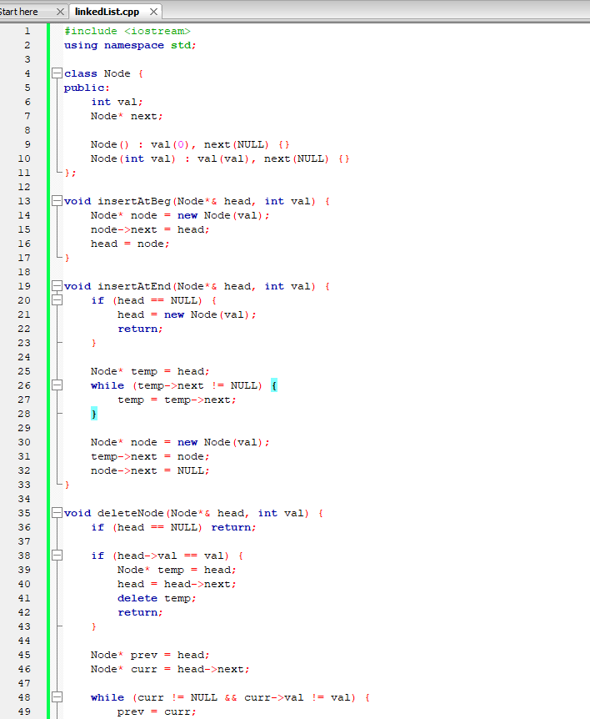

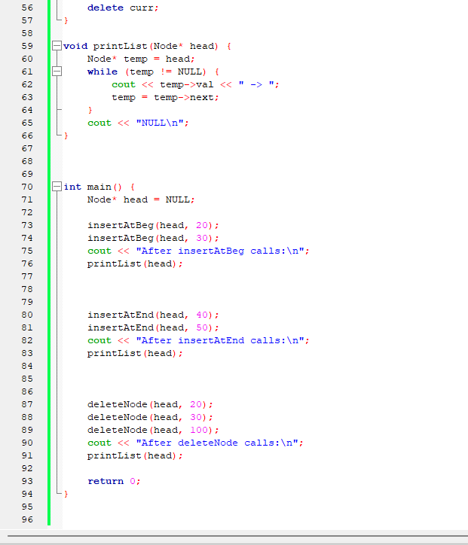

Output:
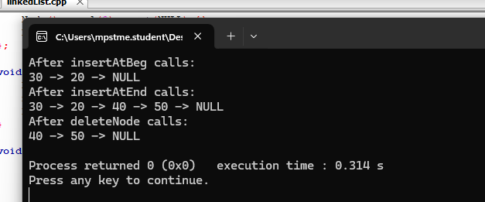
Observation & Learning:
Write your Observations & Learning after performing task
Curiosity questions:
- What will be the output of the following code snippet for the list 1->2->3->4->5->6?
void solve(struct node* start)
{
if(start == NULL)
return;
printf("%d ", start->data);
if(start->next != NULL )
solve(start->next->next);
printf("%d ", start->data);
}
- 1 2 3 4 5 6
- 1 3 5 5 3 1
- 1 3 5 1 3 5
- 2 4 6 1 3 5

Correct answer: b. 1 3 5 5 3 1

- Insertion of an element at the middle of a linked list requires the modification of how many pointers?
- 2
- 1
- 3
- 4

Correct answer: a. 2
Conclusion:
We successfully implemented linked list and its operations using C++ program. .

